**File Name:** Lab9.py

**Contributors:** Jesus A. Bernal Lopez, Paul Whipp, & Michael Avalos-Garcia

**Date:** 2/26/19

**Description:** In this lab we are experimenting and implementing a GUI using python.

**Task1:** This task was the toughest because making a screen is tons of work





**Task2:** In this task we took most of the code from the slides and modified the name of the GUI.

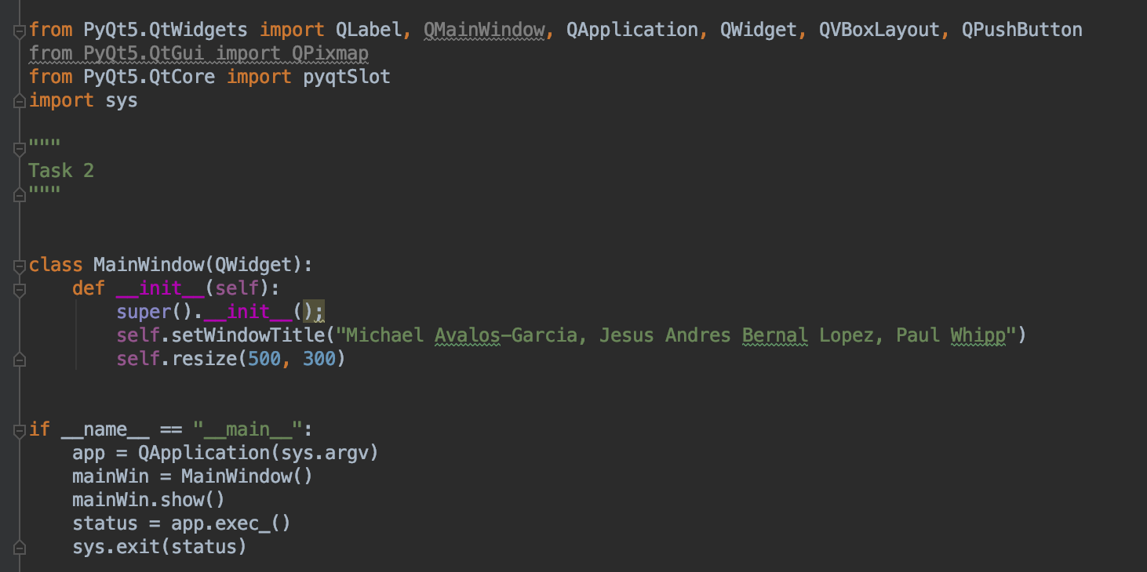

Result:

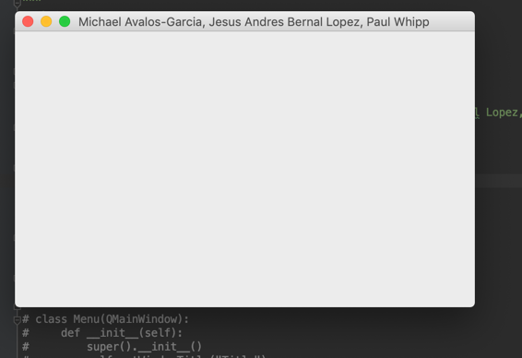

**Task3:** In this task we had a little fun choosing the image to use, we had trouble resizing the image to be proportionate to the initial window size but other than that it was straightforward.

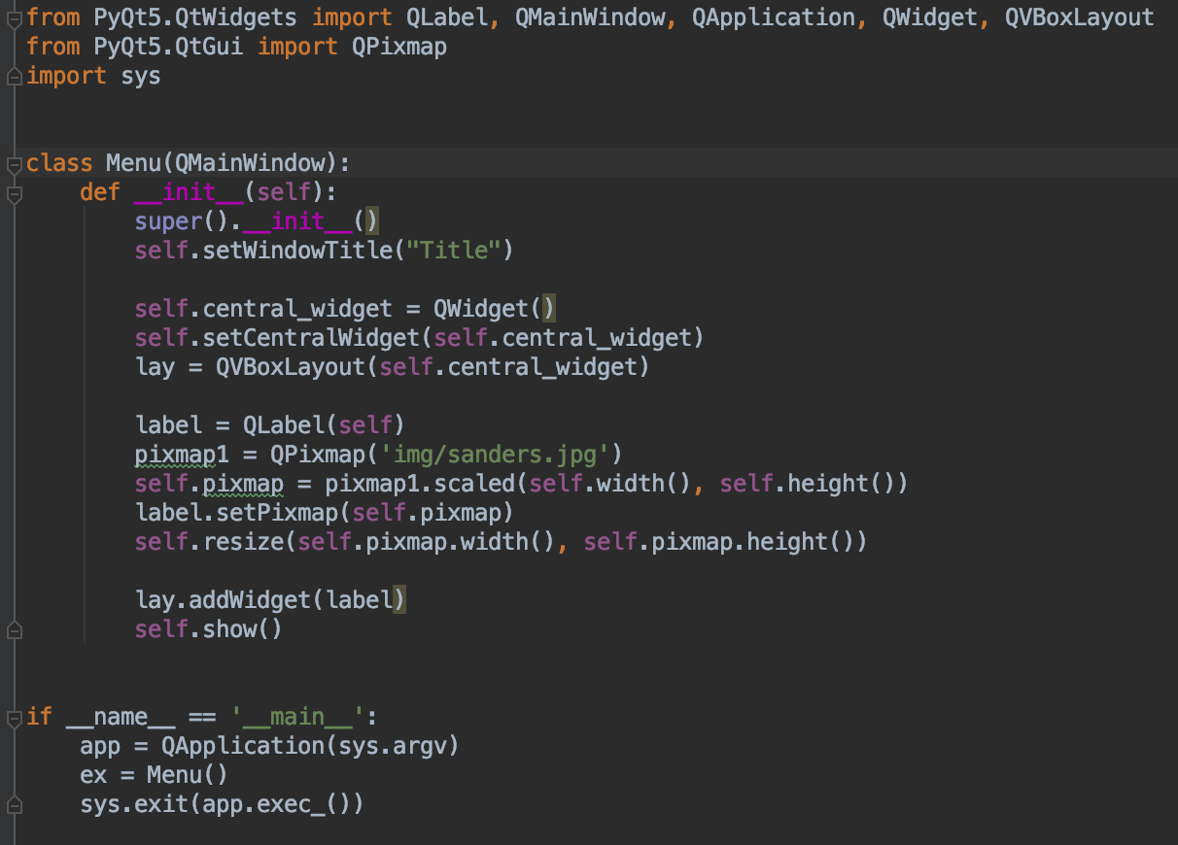

**Result:**

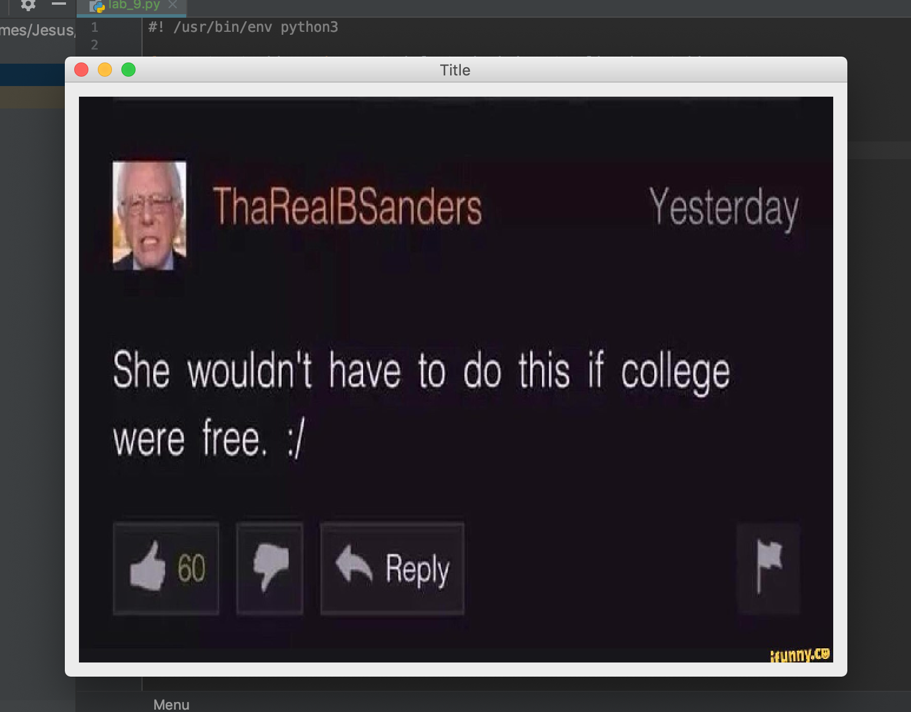

**Task4:** In this task we took the code from the button slide and expanded on it, everything went smoothly here

from PyQt5.QtWidgets import QLabel, QMainWindow, QApplication, QWidget, QVBoxLayout, QPushButton  
from PyQt5.QtCore import pyqtSlot  
import sys

class MainWindow(QWidget):  
 *"""Expanding the QWidget class"""* def __init__(self):  
 super().__init__()  
 self.setWindowTitle("Michael Avalos-Garcia, Jesus Andres Bernal Lopez, Paul Whipp")  
 self.resize(500, 300)  
  
 vbox = QVBoxLayout()  
  
 # Make 3 buttons and label  
 self.michael_btn = QPushButton("Michael", self)  
 self.michael_lbl = QLabel('Michael', self)  
 self.michael_btn.clicked.connect(self.michael_clicked)  
  
 self.jesus_btn = QPushButton("Jesus", self)  
 self.jesus_lbl = QLabel('Jesus', self)  
 self.jesus_btn.clicked.connect(self.jesus_clicked)  
  
 self.paul_btn = QPushButton("Paul", self)  
 self.paul_lbl = QLabel('Paul', self)  
 self.paul_btn.clicked.connect(self.paul_clicked)  
  
 # Add the buttons and labels to the layout  
 vbox.addWidget(self.michael_btn)  
 vbox.addWidget(self.michael_lbl)  
 vbox.addWidget(self.jesus_btn)  
 vbox.addWidget(self.jesus_lbl)  
 vbox.addWidget(self.paul_btn)  
 vbox.addWidget(self.paul_lbl)  
   
 # Setting the layout to our created layout  
 self.setLayout(vbox)  
  
 @pyqtSlot()  
 def michael_clicked(self):  
 *"""Handles the action when this button is clicked"""* self.__set_default__()  
 self.michael_lbl.setText("You have clicked on Michael")  
  
 @pyqtSlot()  
 def jesus_clicked(self):  
 *"""Handles the action when this button is clicked"""* self.__set_default__()  
 self.jesus_lbl.setText('You have clicked on Jesus')  
  
 @pyqtSlot()  
 def paul_clicked(self):  
 *"""Handles the action when this button is clicked"""* self.__set_default__()  
 self.paul_lbl.setText('You have clicked on Paul')  
  
 def __set_default__(self):  
 *"""Updates the labels to their original message"""* self.michael_lbl.setText('Michael')  
 self.jesus_lbl.setText('Jesus')  
 self.paul_lbl.setText('Paul')  
 self.paul_lbl.adjustSize()  
 self.jesus_lbl.adjustSize()  
 self.michael_lbl.adjustSize()  
  
  
if __name__ == "__main__":  
 app = QApplication(sys.argv)  
 mainWin = MainWindow()  
 mainWin.show()  
 status = app.exec_()  
 sys.exit(status)

**Result:**

